**Wireless PDA/EDAs(uncategorized)**

<https://www.alibaba.com/product-detail/Rfid-Pda-BX6200-Android-10-0_1600127191898.html?spm=a2700.galleryofferlist.p_offer.d_image.3ce737568ZaUuO&s=p>

**Price:** 2 pieces US$300.00 to US$400.00

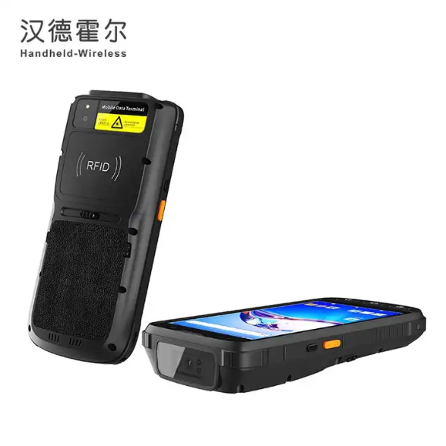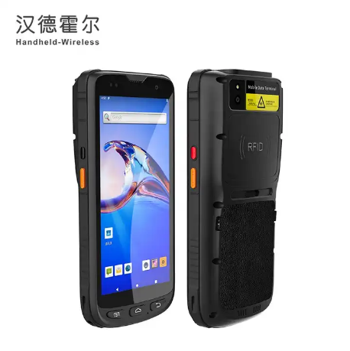

**Product Name:** GAOTek Barcode Scanner

**Product ID:** GAOTek-WPE-201

**Overview:** GAOTek Barcode Scanner serial products are embedded with Android 10.0, as pioneer in this industry. GMS certificated shall product high-standard security level together with ultimate experience. It provides the optional memory selection of 2GB RAM/16GB or 4GB RAM/64GB ROM to match the high-standard project requirements. Dual-Frequency WIFI with protocol of IEEE802.11 a/b/g/n/ac shall match different tough projects which require real-time data communication, especially WIFI seamless roaming in large are houses.

**Technical Specifications:**

|  |  |  |
| --- | --- | --- |
| **Display** | Gorilla Glass 3 9 H 5.5 in. TFT-LCD (720 x1440) touch screen with backlight | |
| **Backlight** | LED backlight | |
| **Battery** | Rechargeable li-ion polymer, 3.8V, 4800mAh | |
| **CPU** | Cortex A73 2.0GHz octa-core | |
| **Operating System** | Android 10.0 | |
| **Storage** | 2 GB RAM / 16 GB ROM or 4 GB RAM / 64 GB ROM, MicroSD (max 256 GB expansion) | |
| **Sealing** | IP65, IEC compliance | |
| **ESD** | ±15kv air discharge, ±8kv direct discharge | |
| **SDK** | Handheld-Wireless Software Development Kit | |
| **Language** | Java | |
| **Environment** | Android Studio or Eclipse | |
| **WLAN** | 2.4 GHz or 5.0 GHz Dual Frequency, IEEE 802.11 a/b/g/n/ac | |
| **WPAN** | Bluetooth Class v2.1+EDR, Bluetooth v3.0+HS, Bluetooth v4.2 | |
| **GPS** | GPS(embedded A-GPS), accuracy of 5 m | |
| **1D laser engine** | Honeywell N4313 | |
| **Symbologies** | All major 1D barcodes | |
| **2D CMOS Imager** | Zebra SE4710 or Mindelo ME5600 | |
| **Symbologies** | PDF417, MicroPDF417, Composite, RSS, TLC-39, Data matrix, QR code, Micro QR code, Aztec, Maxi Code, Postal Codes, US Post Net, US Planet, UK Postal, Australian Postal, Japan Postal, Dutch Postal. etc. | |
| **Resolution** | Rear 13 megapixel, front 5.0 megapixel | |
| **Lens** | Auto-focus with LED flash | |
| **Sensor** | TCS1xx | |
| **Sensor type** | Capacitive, area sensor | |
| **Resolution** | 508 DPI | |
| **Performance** | FRR greater than 0.008%, FAR greater than 0.005% | |
| **Capacity** | 1000 | |
| **Protocol** | ISO 7816 | |
| **Baud rate** | 9600, 19200, 38400,43000, 56000, 57600, 115200 | |
| **Slot** | 2 slots(maximum) | |
| **Standard** | | 1xPower Supply; 1xLithium Polymer Battery; 1xType-C cable |
| **Humidity** | | 5%RH to 95%RH (non-condensing) |
| **Storage Temp.** | | -4 °F to 158 °F (-20 ℃ to 70 ℃) |
| **Operating Temp.** | | -4 °F to 122 °F (-20 ℃ to 50 ℃) |
| **Dimension** | | 6.5 in x 3.1 in x 2.1 in (166 mm x 79 mm x 27 mm) |
| **Weight** | | 0.88 lb (0.4 kg ) (including battery wrist strap) |

<https://www.alibaba.com/product-detail/Rfid-Pda-15-Meters-Android-10_1600115516829.html?spm=a2700.galleryofferlist.p_offer.d_image.3ce737568ZaUuO&s=p>

**Price:** 2 pieces US$400.00 to US$550.00

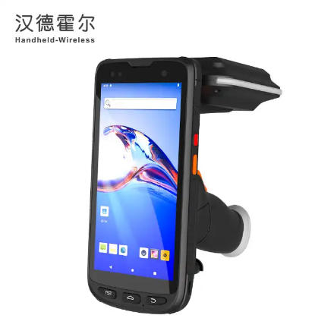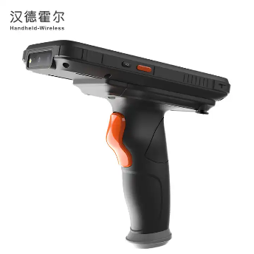

**Product Name:** GAOTek Handheld PDA reader

**Product ID:** GAOTek-WPE-202

**Overview:** GAOTek Handheld PDA Reader are embedded with Android 10.0, as pioneer in this industry. GMS certificated shall product high-standard security level together with ultimate experience**.** Dual-Frequency WIFI with protocol of IEEE802.11 a/b/g/n/ac shall match different tough projects which require real-time data communication, especially WIFI seamless roaming in large are house. It carry Impinj R2000 UHF module and sophisticated antenna design which supports omnidirectional reading with reading distance up to 20 meters (based on Alien 9662 standard white card) in open area. Incomparable reading distance and brilliant performance shall make it inherent & talent product for the projects.

**Technical Specifications:**

|  |  |
| --- | --- |
| **Display** | Gorilla Glass 3 9 H 5.5 in. TFT-LCD (720 x 1440) touch screen with backlight |
| **Backlight** | LED backlight |
| **Expansions** | 1 PSAM, 1 SIM, 1 TF |
| **Battery** | Rechargeable li-ion polymer, 3.8V, 9000mAh |
| **CPU** | Cortex A73 2.0GHz octa-core |
| **Operating System** | Android 10.0 |
| **Storage** | 2 GB RAM/16 GB ROM or 4 GB RAM/64 GB ROM, MicroSD(max 256GB expansion) |
| **ESD** | ±15 kv air discharge, ±8 kv direct discharge |
| **SDK** | Handheld-Wireless Software Development Kit |
| **Language** | Java |
| **Environment** | Android Studio or Eclipse |
| **WLAN** | 2.4 GHz or 5.0GHz Dual Frequency, IEEE 802.11 a/b/g/n/ac |
| **WPAN** | Bluetooth Class v2.1+EDR, Bluetooth v3.0+HS, Bluetooth v4.2 |
| **GPS** | GPS(embedded A-GPS), accuracy of 5 m |
| **2D CMOS Imager** | Zebra SE4710/Mindeo ME5600 |
| **Symbologies** | PDF417, MicroPDF417, Composite, RSS, TLC-39, Datamatrix, QR code, Micro QR code, Aztec, MaxiCode, Postal Codes, US PostNet, US Planet, UK Postal, Australian Postal, Japan Postal, Dutch Postal. etc. |
| **Resolution** | Rear 13 megapixel, front 5.0 megapixel |
| **Lens** | Auto-focus with LED flash |
| **Frequency** | 13.56 MHz |
| **Protocol** | ISO 7816 |
| **Baudrate** | 9600, 19200, 38400,43000, 56000, 57600, 115200 |
| **Slot** | 2 slots(maximum) |
| **Standard** | 1xPower Supply; 1xLithium Polymer Battery; 1xType-C cable |
| **Optional** | Cradle |
| **Humidity** | 5%RH to 95%RH (non-condensing) |
| **Storage Temp.** | -4 °F to 158 °F (-20 ℃ to 70 ℃) |
| **Operating Temp.** | -4 °F to 122 °F (-20 ℃ to 50 ℃) |
| **Dimension** | 6.5 in x 3.1 in x 2.1 in (166 mm x 79 mm x 27 mm) |
| **Weight** | 0.88 lb (0.4 kg ) (including battery &wrist strap) |

<https://www.alibaba.com/product-detail/IP67-Industrial-Rugged-Android-11-0_1600612592983.html?spm=a2700.galleryofferlist.p_offer.2.3ce737568ZaUuO&s=p>

**Prices:** 1 to 49 pieces US$265.00

0 to 199 pieces US$255.00

>= 200 pieces US$245.00

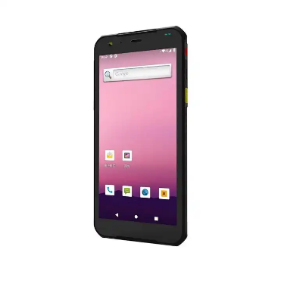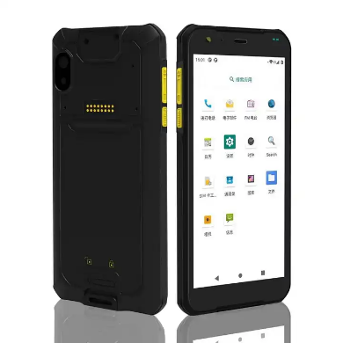

**Product Name:** GAOTek handheld wireless mobile

**Product ID:** GAOTek-WPE-203

**Meta Description:** This Handheld Wireless Mobile has a display of 5.7inch LCD, battery capacity of 3.85 V or 4500 Mah and a cell voltage AC 100 V to 240 V,50 Hz.

**Features:**

* Android 11.0 OS
* Memory:4 GB + 64 GB
* IP67 industrial design,1.5m fall resistance
* Big battery capacity: 4500 mAH
* Barcode scanner:2d scanner

**Technical Specifications:**

|  |  |
| --- | --- |
| **CPU Dominant frequenc** | 8 Core 2.0 GHZ Quadrupolar nuclei |
| **OS** | Android 11.0 |
| **Memory** | 4 GB + 64GB |
| **Display** | 5.7inch LCD,1440 x 720 TFT |
| **Touch** | Capacitive screen or Resistive Touch Panel |
| **Output** | Stereo speaker output, video playback |
| **SD/TF** | 32 GB |
| **Standby Current** | 3 mAh |
| **Working current** | 180 mAh |
| **Battery capacity** | 3.85 V or 4500 MAH |
| **Battery voltage** | 3.4 V to 4.2 V |
| **Stand-by time** | 1500h |
| **Working hours** | 15h |
| **Development platform** | C,JAVA |
| **Cell voltage** | AC 100–240V,50 or 60Hz |
| **Camera** | 13 Million Pixels |
| **Read-write distance** | 0 mm to 60 mm |
| **2D Barcode Terminal brand** | N6703 |
| **2D Barcode Bar code type** | Code39,PDF417,Data Matrix |
| **2D Barcode Working current** | 450 mA |
| **Storage temperature** | -4 °F to 165 °F (-20 ℃ to 80 ℃) |
| **Temperature** | 5 °F to 129 °F (-15 ℃ to 65 ℃) |
| **Dimension** | 6.3 in x 3 in x 0.5 in (162 mm x 76.2 mm x 13.7 mm) |
| **Weight** | 0.529 lb (0.24 kg) |

<https://www.alibaba.com/product-detail/Handheld-Pda-Android-7-0-Handheld_62026457327.html?spm=a2700.galleryofferlist.p_offer.d_title.3ce737568ZaUuO&s=p>

**Prices:** 1 to 49 pieces US$249.00

50 to 199 pieces US$239.00

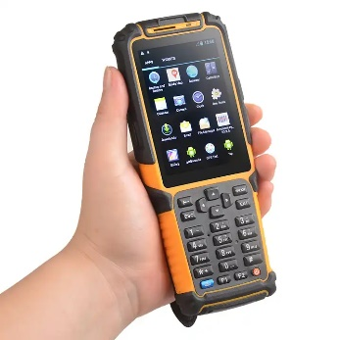>= 200 pieces US$229.00

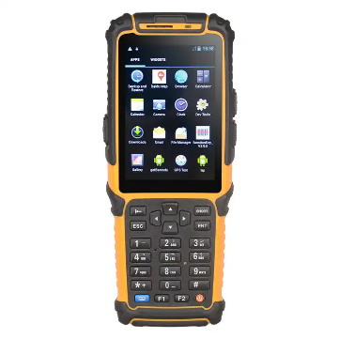

**Product Name:** GAOTek Handheld Wireless Industrial Mobile

**Product ID:** GAOTek-WPE-204

**Meta Description:** This Handheld Wireless Industrial Mobile has a cell voltage of AC 100 V to 240 V, standby current below 3 mAh and a display of 3.5inch LCD.

**Features:**

* Android 7.0 OS
* Memory:1 GB + 8 GB (SD/TF:32GB)
* IP64 industrial design,1.5m fall resistance
* Big battery capacity: 3800 mAH
* Barcode scanner: Symbol SE965; Symbol SE4750

**Technical Specifications:**

|  |  |
| --- | --- |
| **CPU Dominant frequenc** | 1.2 GHz,Cortex A9 |
| **OS** | Android 7.0 |
| **Memory** | 8 GB+1 GB |
| **Display** | 3.5inch LCD,320 x 480TFT |
| **Touch** | Capacitive screen or Resistive Touch Panel |
| **Communication** | WIFI ,GPS,Bluetooth,Radio,4G/WCDMA/EDGE/GSM,USB,UART |
| **External input** | 27 full keyboard input, audio input |
| **Output** | Stereo speaker output, video playback |
| **SD/TF** | 32 GB |
| **Standby Current** | below 3 mAh |
| **Working current** | 180 mAh |
| **Battery capacity** | 3800 MAH |
| **Battery voltage** | 3.4V to 4.2V |
| **Stand-by time** | over 1500h |
| **Working hours** | over 15h |
| **Development platform** | C, JAVA |
| **Cell voltage** | AC 100 V to 240 V, 50 Hz or 60 Hz |
| **Camera** | 5.0Million Pixels. Take a picture Camera shooting |
| **Charging current** | 800 mA |
| **Storage temperature** | -4 °F to 165 °F (-20 ℃ to 80 ℃) |
| **temperature** | 5 °F to 129 °F (-15 ℃ to 65 ℃) |
| **Dimension** | 6.8 in x 2.0 in x 1.1 in (175 mm x 66 mm x 30 mm) |
| **Weight** | 0.55 lb (0.23 kg) |

<https://www.alibaba.com/product-detail/Urovo-8-Inch-Android-9-0_1600592500051.html?spm=a2700.galleryofferlist.p_offer.d_title.3ce737568ZaUuO&s=p>

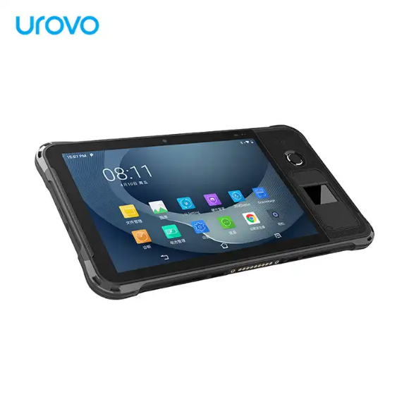**Price:** 1 piece US$400.00 to US$470.00

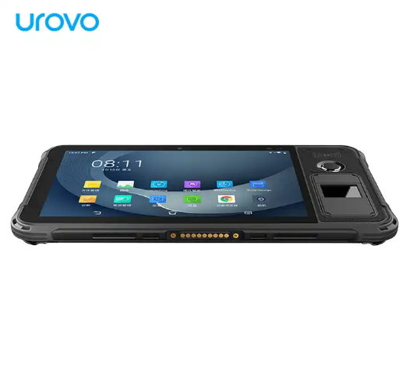

**Product Name:** GAOTek Rugged industrial tablet

**Product ID:** GAOTek-WPE-206

**Meta Description:** This Rugged industrial tablet has a display of 8inch electromagnetic display HD ,reliability of MTBF less than 50000h and a RH of 5% RH to 95% RH.

**Technical Specifications:**

|  |  |
| --- | --- |
| **CPU** | Octa-core 1.8 Ghz |
| **GPU** | Qualcomm® Adreno™ 506 PC |
| **OS** | Android 9.0 |
| **RAM** | 4 GB |
| **Internal Memory** | 64 GB |
| **External Memory** | Micro-SD card, Up to 256 GB |
| **Scanner** | Zebra SE4710 |
| **Main Camera** | Rear 13 M Pixels Flashlight |
| **Sub Camera** | Front 5M Pixels |
| **Battery** | 3.8 V or 8400 mAh Rechargeable Lithium Battery |
| **Display** | 8inch display，1280 x 800（HD） |
| 8inch electromagnetic display ,1920×1200（FHD） （optional） |
| **Touch Panel** | Capacitive： at least five touches， support gloves touch （ thickness 3.5mm）, wet finger and passive stylus signature Electromagnetic |
| display optional）：at least five touches， support gloves touch （ thickness 3.5mm ）, wet finger and passive stylus signature |
| **SIM Card** | 1.5 V or 3.3 V or 5 V |
| **TF Card** | Micro-SD card, up to 256 GB |
| **Headphone** | 0.13 in (3.5 mm) |
| **Charging interface** | Type-C x 1 |
| **Data interface** | USB Type-C |
| **Charger** | 5.0 V 3 A to 15 W |
| **2G/2G Band** | GSM/CDMA 1X/EDGE/GPRS (850/900/1800/1900) |
| **3G/3G Band** | WCDMA(B1/B2/B4/B5/B8) TD-SCDMA(B34/B39) CDMA2000 1x EV-DO Rev.A BC0 (800MHz) |
| **4G/4G Band** | TD-LTE: B34/B38/B39/B40/B41 FDD-LTE (B1/B2/B3/B4/B5/B7/B8/B12/B13/B17/ B19/B20/B25/B26/B28A/B28B/B66) |
| **WI-FI** | IEEE 802.11a/b/g/n/ac/d/e/h/i/k/r/v/w （2.4G/5G dual band WIFI） |
| **Bt** | BT4.2 + BR/EDR + BLE |
| **Shake-proof** | 10-55HZ/2MM |
| **RH** | 5 %RH to 95 %RH (No condensation) |
| **Reliability** | MTBF less than 50000h |
| **Operating** | -4 °F to 140 °F (-20 °C to 60 °C) |
| **Storage Temperature** | -40 °F to 158 °F (-40 °C to 70 °C) |
| **Size** | 9.2 in x 7.2 in x 0.65 in (253.8 mm x 146 mm x 16.5 mm) |
| **Weight** | 1.6 lb (0.77 kg) |

<https://www.alibaba.com/product-detail/Handheld-Rfid-Long-Range-10-Meter_1600490026766.html?spm=a2700.galleryofferlist.p_offer.d_title.3ce737568ZaUuO&s=p>

**Price:** 1 piece US$560.00 to US$700.00

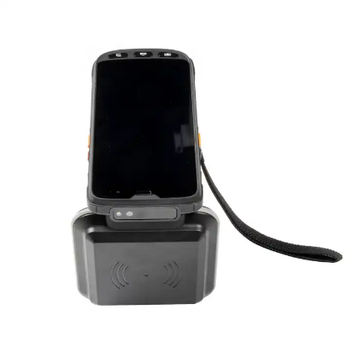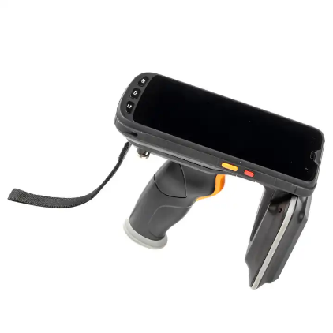

**Product Name:** GAOTek Handheld Reader Industrial PDA

**Product ID:** GAOTek-WPE-206

**Overview:** GAOTek Handheld Reader Industrial PDAindustrial humanized keypad design and tough 5.5 inch Gorilla Glass 3 touch screen together with high resolution of 720 x 1440 display shall match high standards in logistics, express and retail. Android 9.0 OS with memory of 2GB RAM/16GB ROM or 4GB RAM/64GB ROM shall provide the highly standard. Double insurance of 4G &WIFI network and highly secured Android 9.0 system shall provide the high.

**Technical Specifications:**

|  |  |
| --- | --- |
| **Display** | Gorilla Glass 3 9H 5.5 in. TFT-LCD (720 x 1440) touch screen with backlight |
| **Backlight** | LED backlight |
| **Expansions** | 1 PSAM, 1 SIM, 1 TF |
| **Battery** | Rechargeable li-ion polymer, 3.8V, 9000mAh |
| **CPU** | Cortex A73 2.0GHz octa-core |
| **Operating System** | Android 9.0 |
| **Storage** | 2GB RAM/16GB ROM or 4GB RAM/64GB R MicroSD(max 256GB expansion) |
| **Drop Specifications** | 5ft./1.5 m drop to concrete across the operating temperature range |
| **Sealing** | IP65, IEC compliance |
| **ESD** | ±15kv air discharge, ±8kv direct discharge |
| **SDK** | Handheld-Wireless Software Development Kit |
| **Environment** | Android Studio or Eclipse |
| **WWAN** | TDD-LTE Band 38, 39, 40, 41; FDD-LTE Band 1, 2, 3, 4, 7, 17, 20; WCDMA (850/1900/2100MHz); GSM/GPRS/Edge (850/900/1800/1900MHz |
| **WLAN** | 2.4GHz/5.0GHz Dual Frequency, IEEE 802.11 a/b/g/n/ac |
| **WPAN** | BT Class v2.1+EDR, BT v3.0+HS, BT v4.2 |
| **GPS** | GPS (embedded A-GPS), accuracy of 5 m |
| **2D CMOS Imager** | SE4710 SE2100/Others |
| **Resolution** | Rear 20 megapixel, front 5.0 megapixel |
| **Lens** | Auto-focus with LED flash |
| **Low Frequency Frequency** | 125 KHz or 134.2 KHz (FDX-B/HDX) |
| **Low Frequency Protocol** | ISO 11784&11785 |
| **NFC Frequency** | 13.56 MHz |
| **NFC Protocol** | ISO 14443A&15693, NFC-IP1, NFC-IP2 |
| **NFC R/W Range** | (50 mm to 8 mm) |
| **UHF Frequency** | 865 MHz to 868 MHz or 920 MHz to 925MHz |
| **UHF Protocol** | EPC C1 GEN2 ISO 18000-6C |
| **UHF R/W Range** | 0 m to10.0 m (tags and environment dependent) |
| **UHF Antenna Gain** | Circular antenna(3dBi) |
| **Humidity** | 5 % RH to 95 % RH (non-condensing) |
| **Operating Temp** | -4 °F to 122 °F (-20℃ to 50 ℃) |
| **Storage Temp** | -4 °F to 158 °F (-20 ℃ to 70 ℃) |
| **Dimension** | 6.5 in x 3.1 in x 2.1 in (166mm x 79 mm x 31 mm)  (Not including the shield and pistol grip) |
| **Weight** | * 1. lb (0.6 kg) |